DRUM SANDING
AND
MICRO ADJUSTING THE TABLE

PTWFE recommends that no more than 1/64th of an inch (approximately 0.15") be removed in a single pass when using the drum sander to thickness stock. Too heavy a pass can overload the sandpaper, create kickbacks, strain the spindle etc. My experience is that even 1/64th is too much and that it is best to keep each pass to no more than 0.01", and actually 0.008" works even better. After the stock has been reduced nearly to the desired thickness, a finishing pass or two at about 0.004" will leave a nice surface.

I have found that an easy way to make such small adjustments to the table height is by using a stop collar, either the adjustable one or the simple non-adjustable one. When using the adjustable collar, invert it (that is have the fixed ring on the bottom and the movable ring on top), open it up to more than the total thickness that is to be removed and place it on the table tube below the table or the carriage. Adjust the table so that the work piece just barely touches the underside of the drum, lock the table, then snug the collar up against the underside of the table or carriage. Make the first pass. Now spin the adjustable collar closed by 0.008 inches and raise the table until the collar is again snug against the underside of the table or carriage. 0.008" is such a small distance it will seem like the table really hasn't moved at all, but have faith and when you feed the stock into the drum you will feel the resistance and see the sawdust. Continue at 0.008" per pass as needed.

The same thing can be done with a non-adjustable collar. After the first pass, release the collar from the table tube and use a feeler gage set at 0.008" to create a gap between the collar and the underside of the table or carriage. Lock the collar back onto the table tube while maintaining this gap, then raise the table until the collar is snug. Continue until stock has been reduced to the desired thickness.

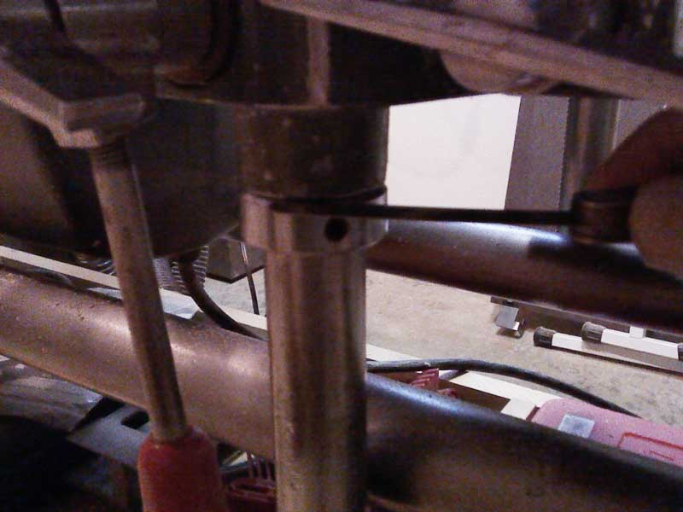
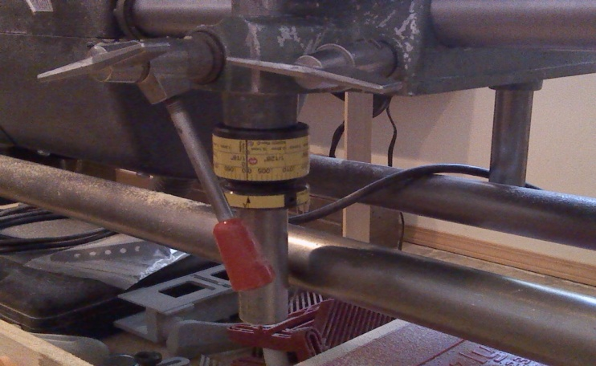
Using feeler gage on non-adjustable Inverted adjustable collar
collar

